953484342

<http://www.kyaqyhb.com/archive_list_en.htm>

Go to the website using the based url.You will get current issue page like below

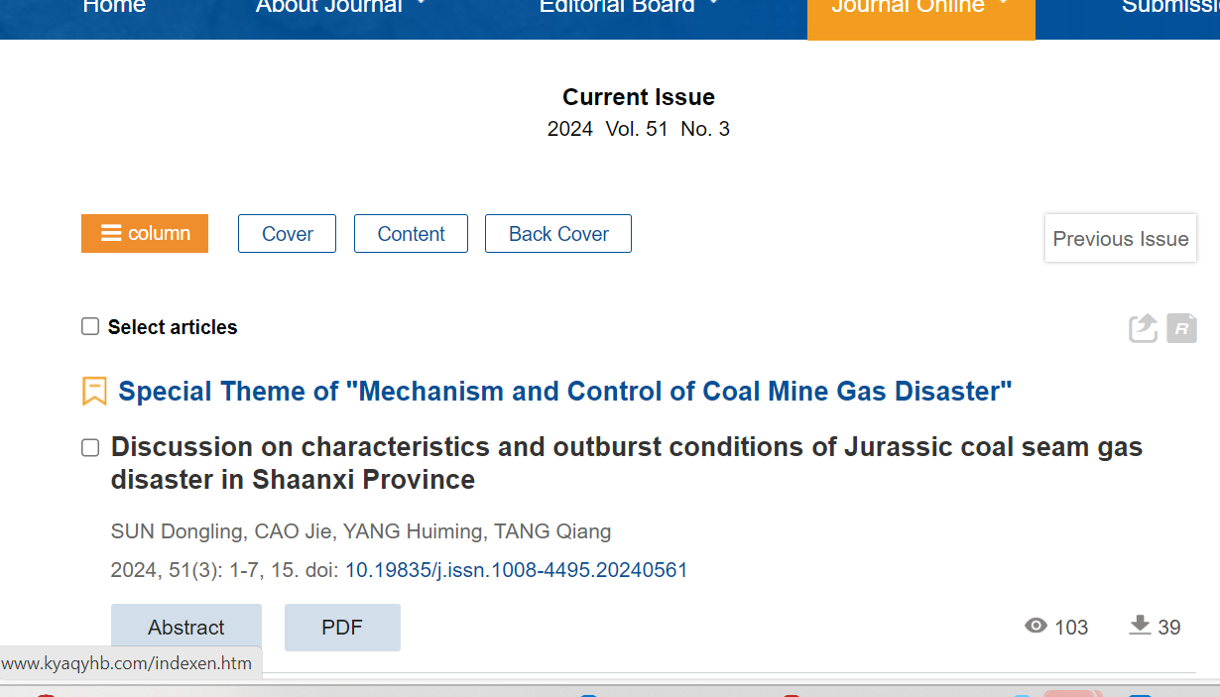

Page range

Download pdf

Capture DOI

Capture title

Capture issue

Capture Volume

Capture year

Need both non roman and English tocs